- Create EC2 instance and name it as ec2-web-server-ins
- For this Select Amazon AMI(RedHat) and select all default options.
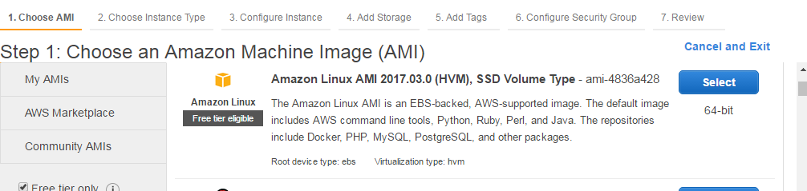
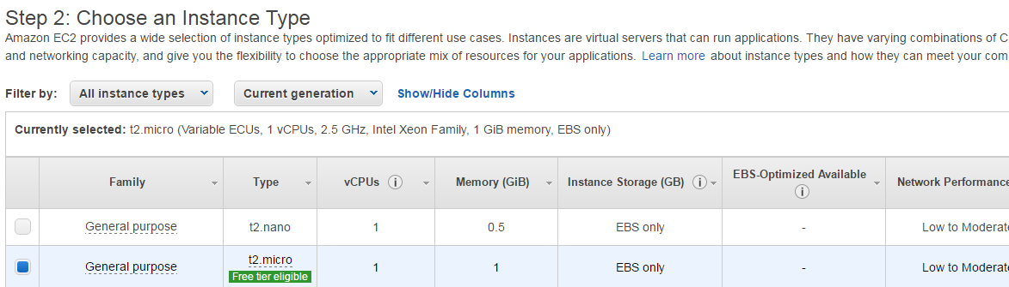
Select subnet as us-west-2a ideally this will be like public network. As we don’t have public custom vpc are not available /created will go with default options
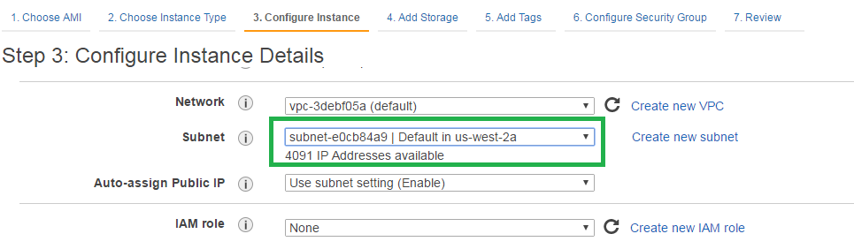

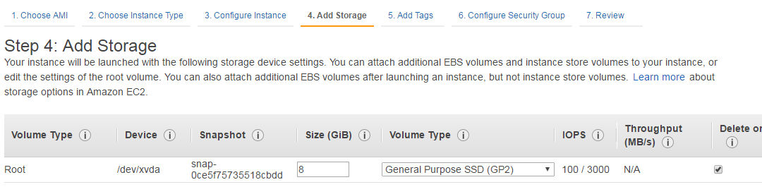
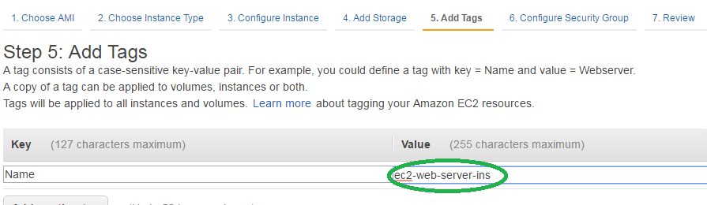
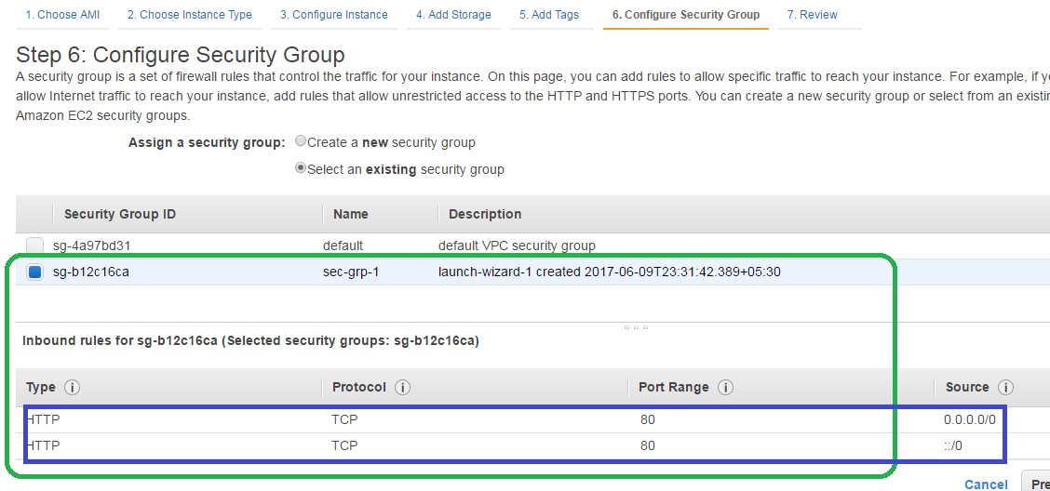
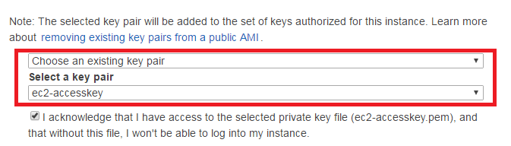
- Once its ‘running’ then install ‘httpd’ and ‘php’. https://www.digitalocean.com/community/tutorials/how-to-install-linux-apache-mysql-php-lamp-stack-on-centos-7
- Select instance from EC2 Instances and click on connect
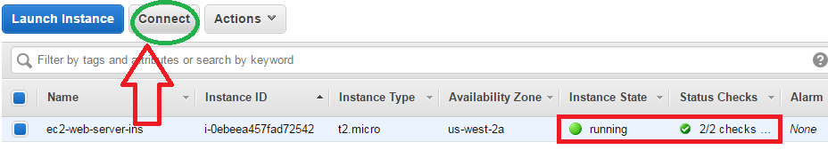
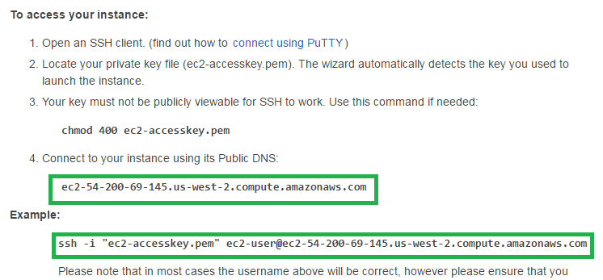
  - Ssh to ec2-web-server-ins machine and install following apps using ‘yum’ packager manager as root user ‘sudo root user’
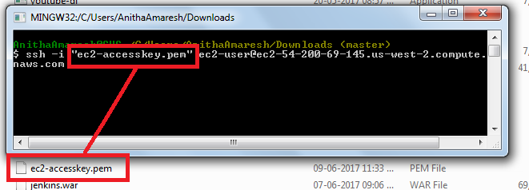
  - login as root user using ‘sudo -i’
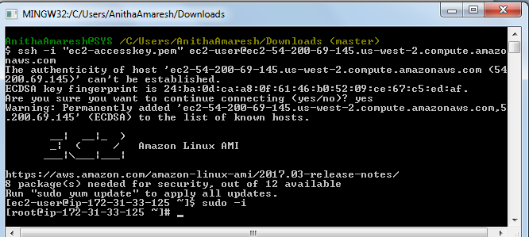

- httpd
  - yum install httpd –y
  - service httpd status
  - service httpd start
  - chkconfig httpd on

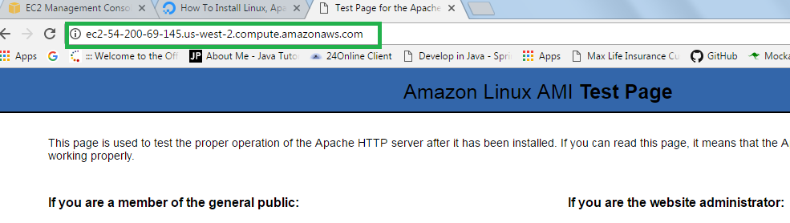
- php
  - yum install php php-mysql -y
  - yum install php-fpm -y
  - vi /var/www/html/index.php
in index.php <?php phpinfo(); ?>
  - service httpd restart

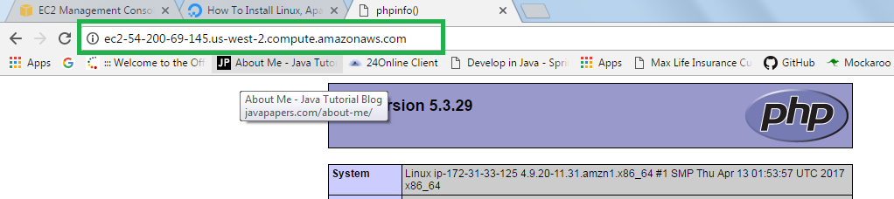

- Once the ec2 instance running with applications then you stop the ec2 instance and create image from ec2 instance.
- Create image ec2-web-server-image from existing ec2 instance ec2-web-server-ins.
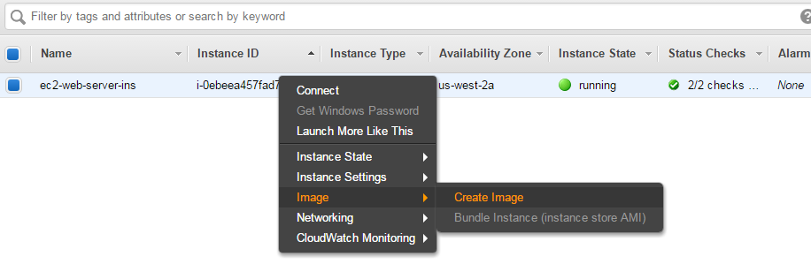
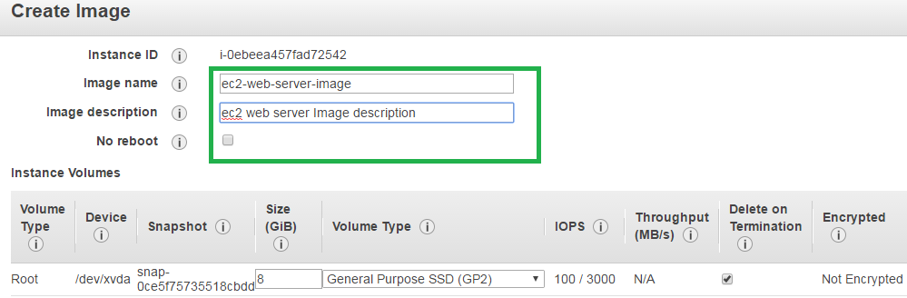

After this ec2-web-server-ins will be restarted and new AMI machine will be created, which will located under ‘My AMI’ or go to IMAGES→AMIs
MY AMI
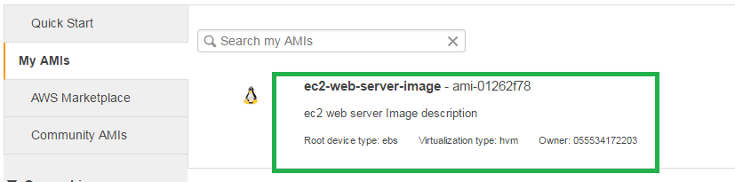

IMAGES→AMIs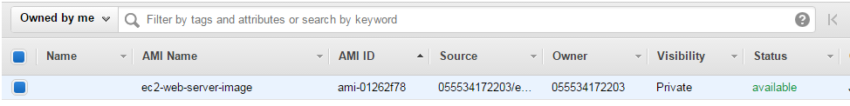

If you observer the status of existing ec2 instance, and it got restarted but not rebooted properly and don’t warry about that, because once AMI/New Image was created we are going to ‘terminate’ the ec2 instance which is no longer required

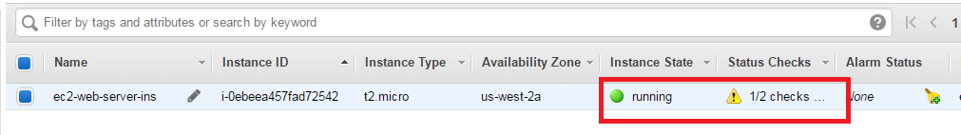

Now create Load Balancer –

Load Balancing → Load Balancers → Create Load Balancer → Classic Load Balancer →
ec2-web-server-elb

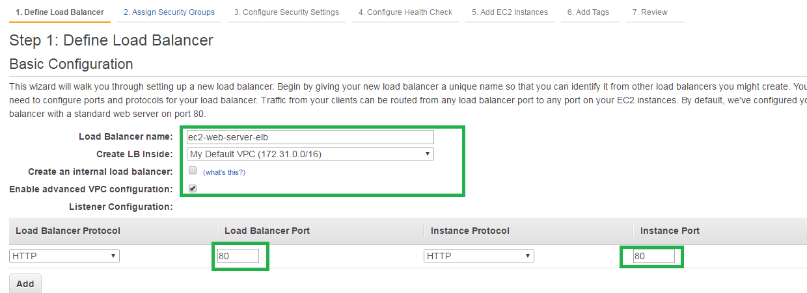
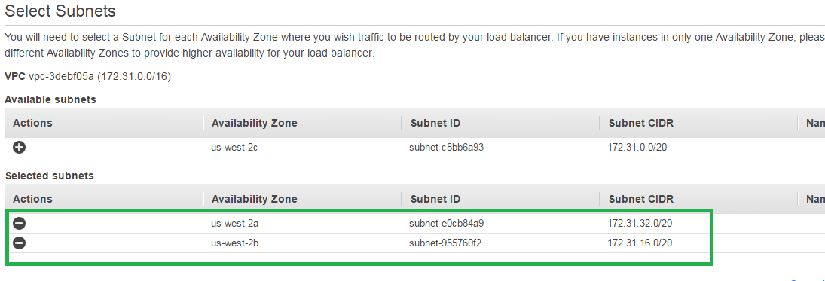
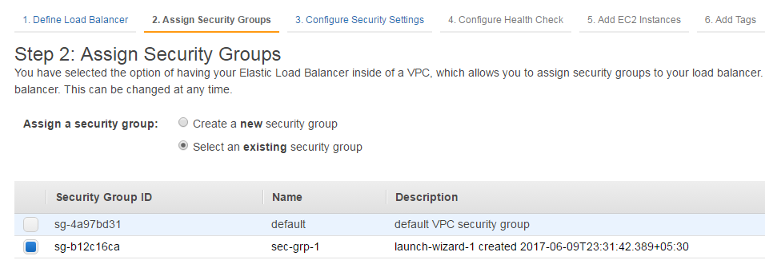

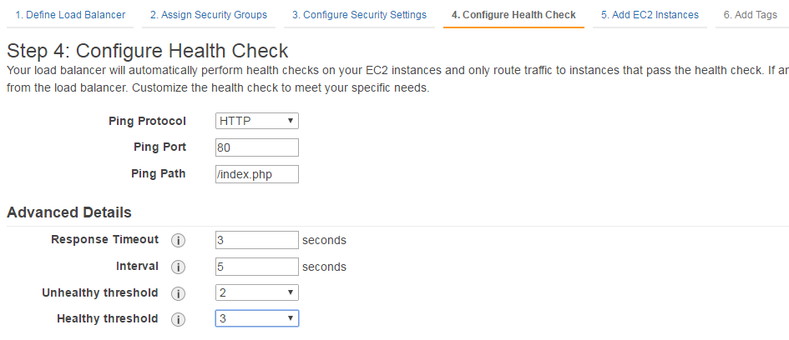
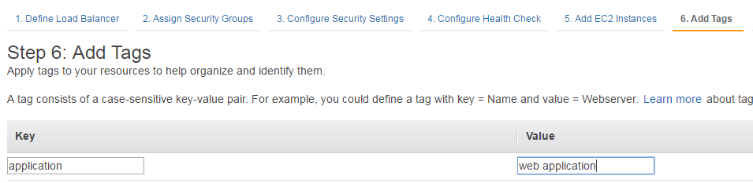

We successfully created Load Balancer we can verify it in below screen.

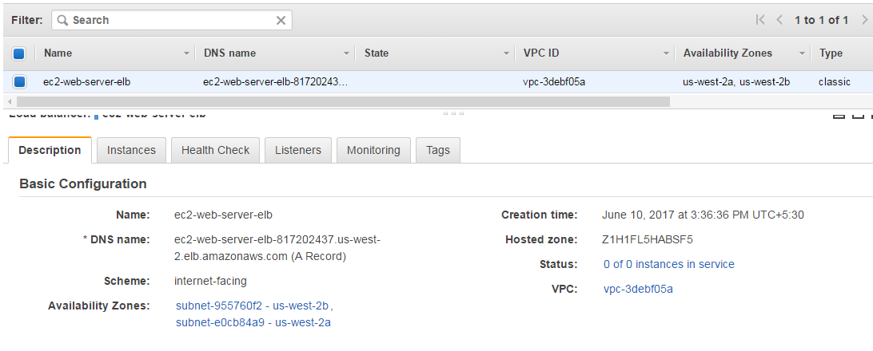

Now we need to do 1. Launch Configuration
2. Auto Scaling Group
To do these go to Auto Scaling → Launch Configuration and Auto Scaling Group.

- Launch Configuration for this we need to select new ec2-web-server-image
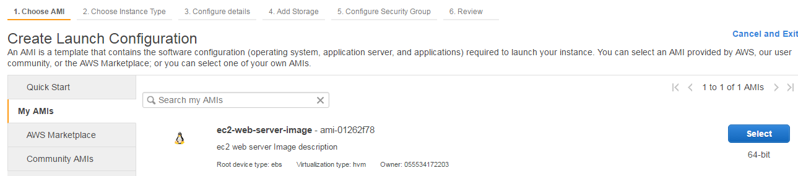
- Go with all default options.
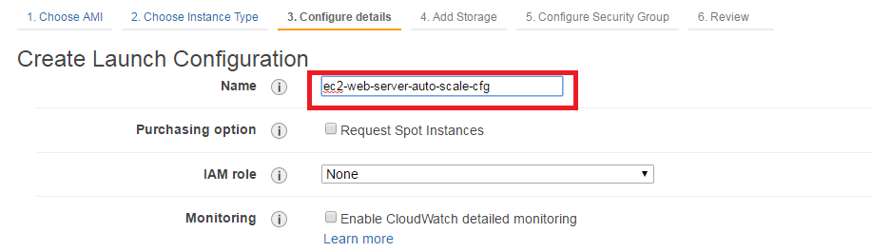

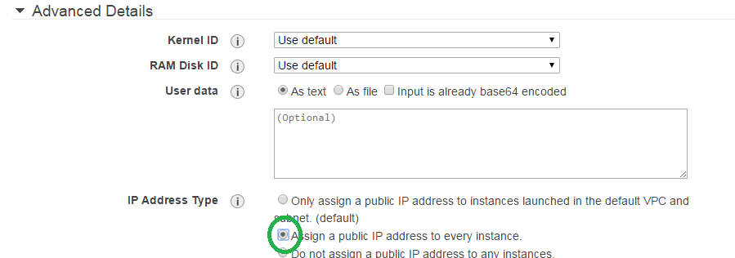

Go with all default options then-

2. Now configure the Auto Scaling Group

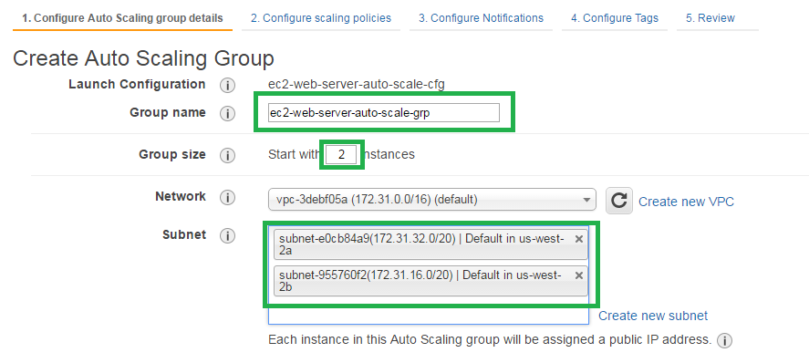
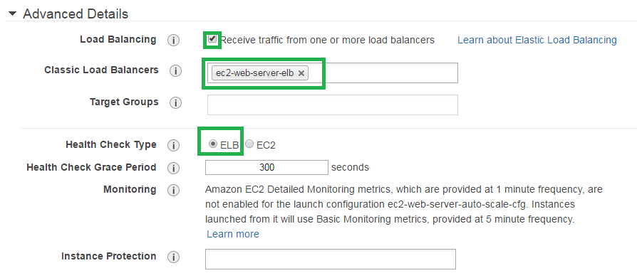
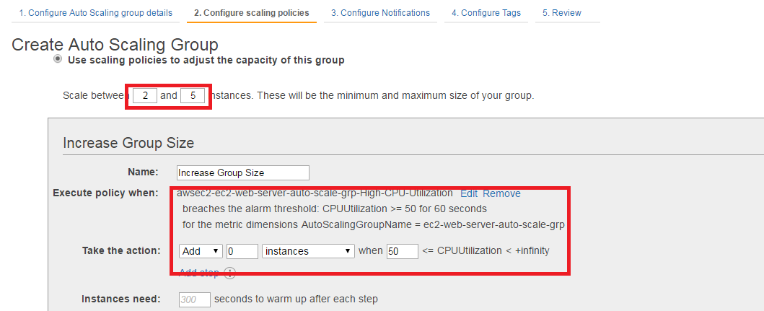

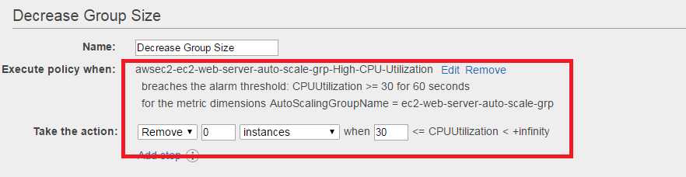
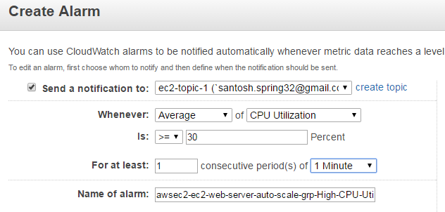
- Go with all default options

Now the we created successfully Launch Configuration and Auto Scaling Group.

Auto Scaling →Auto Scaling Group
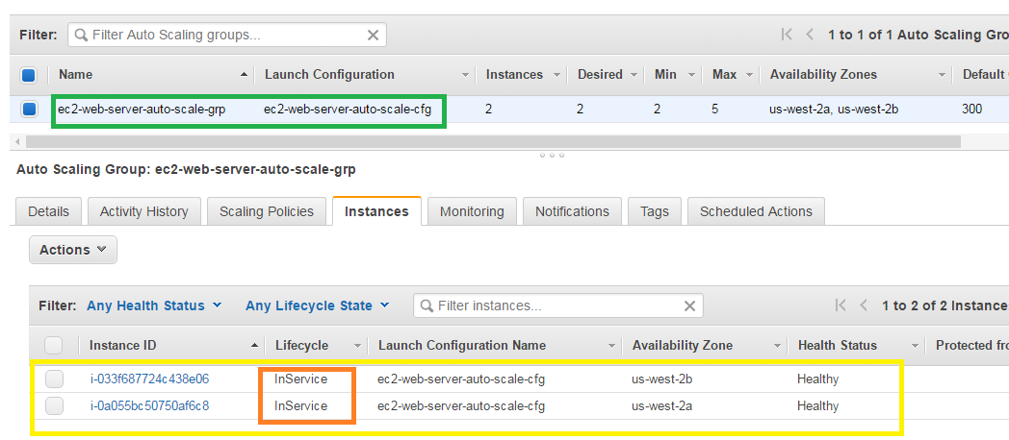

Load Balancing → Load Balancer

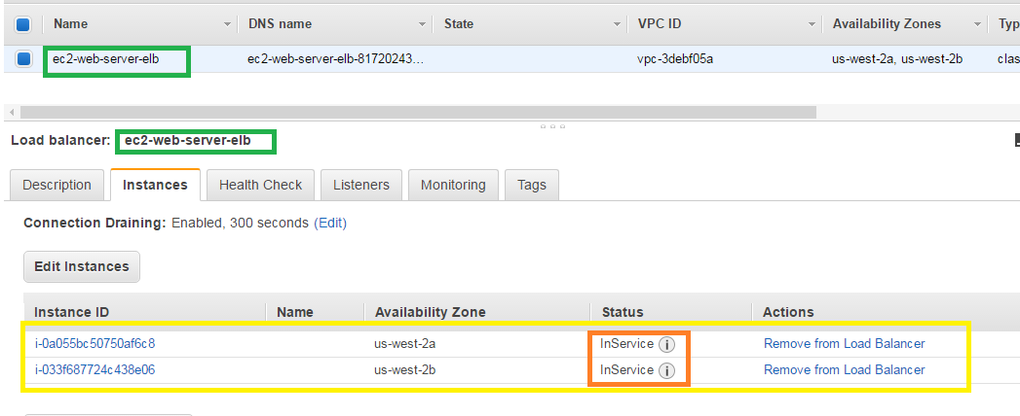

Instances → instances

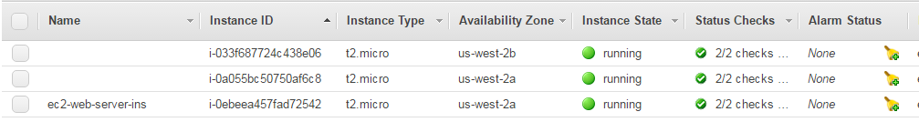

All servers are ready now, so you can access DNS name of Load Balancer (Elastic Load Balancer) then based on traffic request will be routed to free server.

Let try this by using load balancer dns name.Load Balancing →Load Balancer

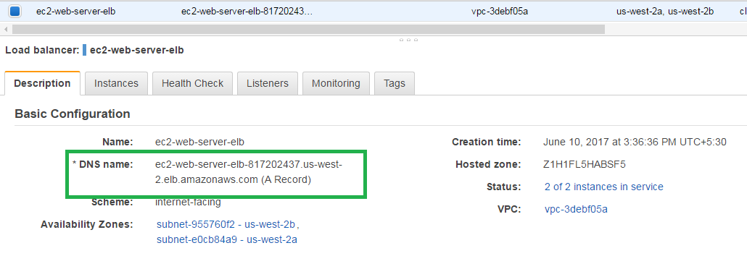
http://ec2-web-server-elb-817202437.us-west-2.elb.amazonaws.com/

